LifeCycle, Request, Response and Web Container

So far, we have discussed

* what a Servlet is
* why do we use a Servlet?
* How the communication takes place in between client and Servlet?

Now we are going to have a look at Servlet LifeCycle.

We are going to see:

* What are the different Lifecycle methods of Servlet are?
* What the different state of Servlet are?
* When are these methods called?

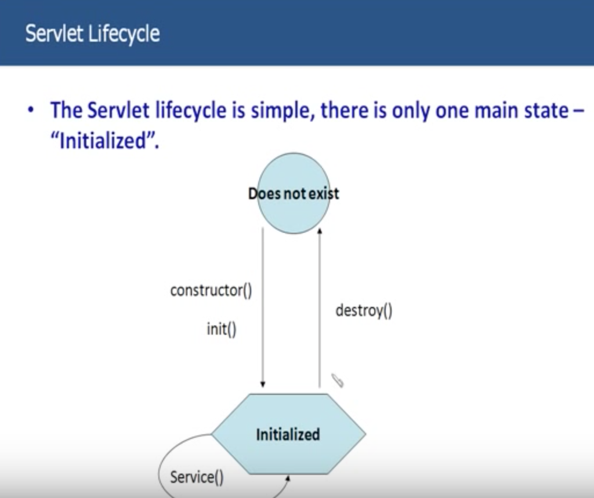

**Hierarchy:**

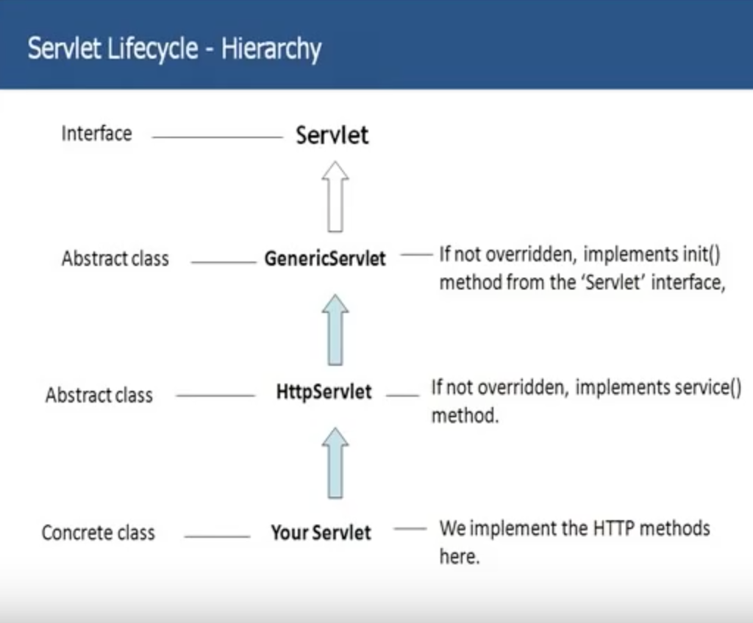 Let’s now discuss different methods of a Servlet and the details of the method like when are they called and what is used for and all those different things.

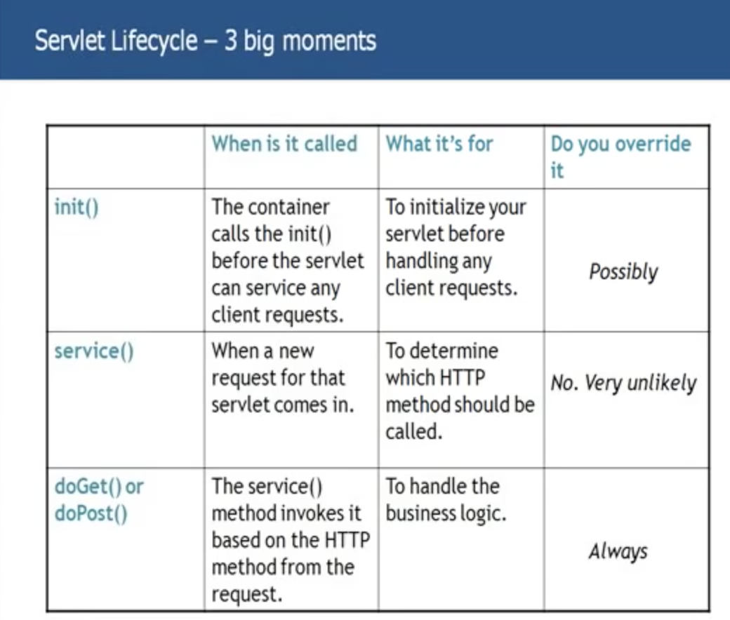

**Thread handling:**

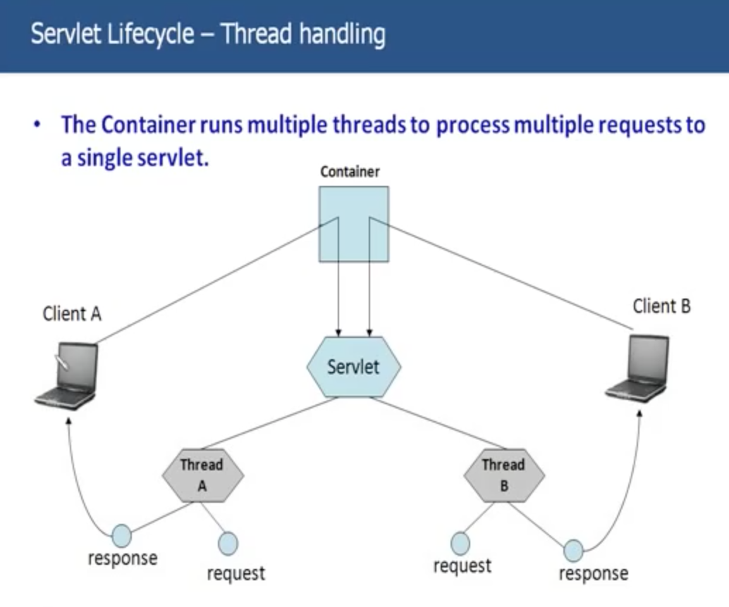

**Request and Response – GET v/s POST:**

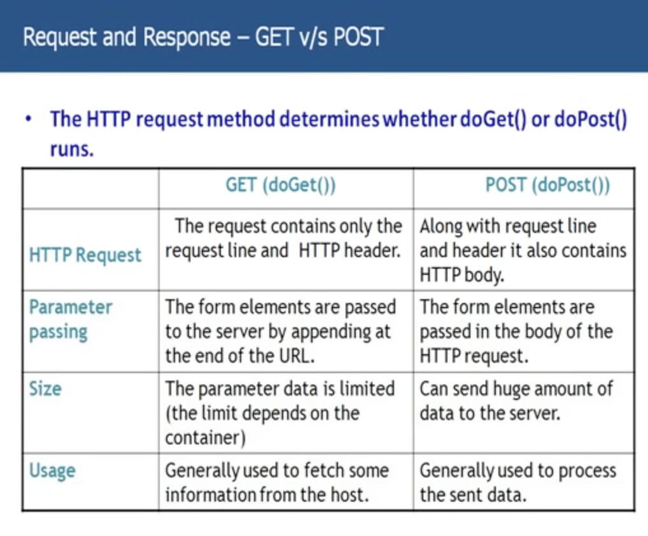

**The Response:**

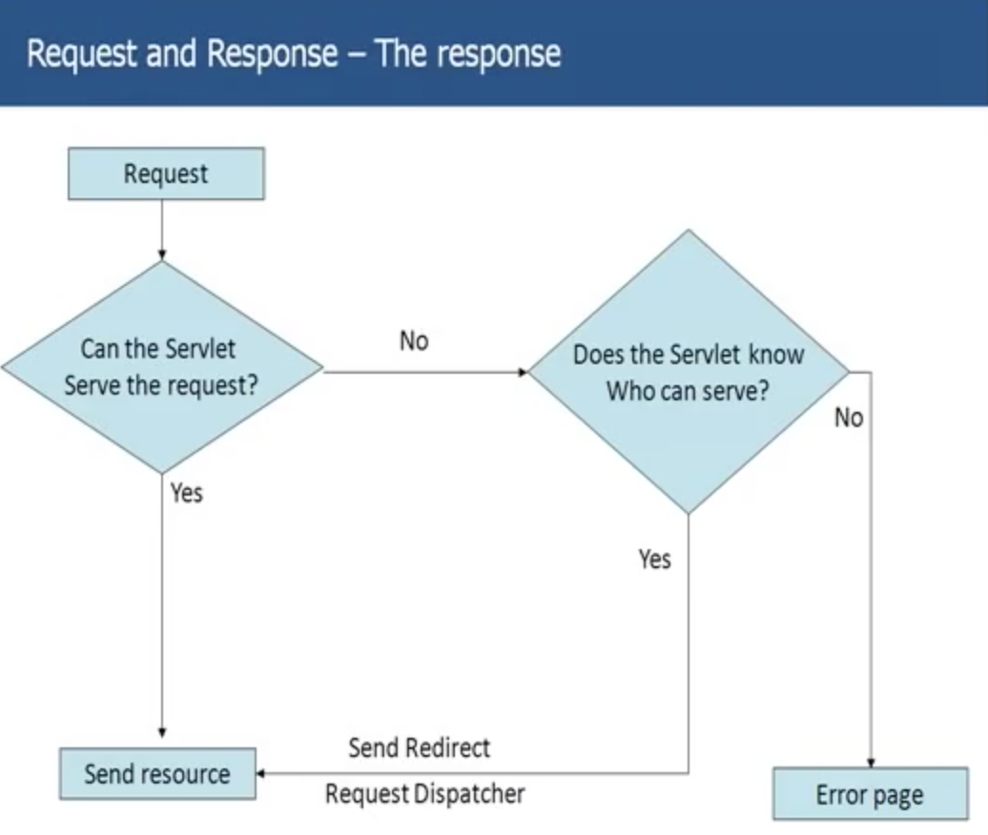

**When to use Send Redirect and when to use Request Dispatcher?**

**Being Web Container - Servlet Config and Context:**

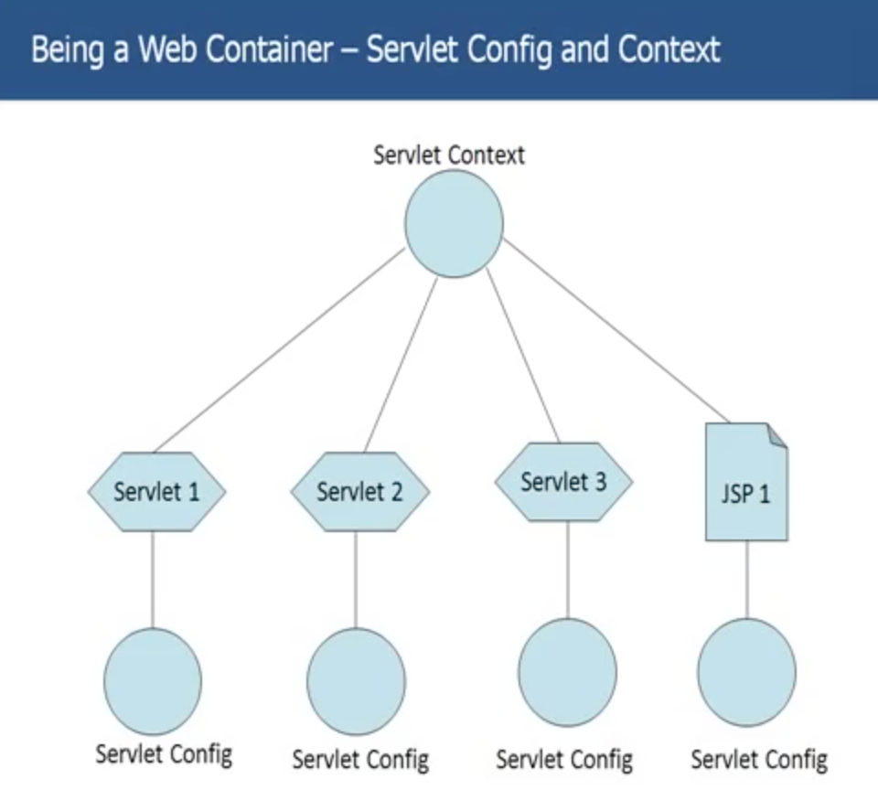

**What can you do with Context and Config objects?**

**What are init parameters?**

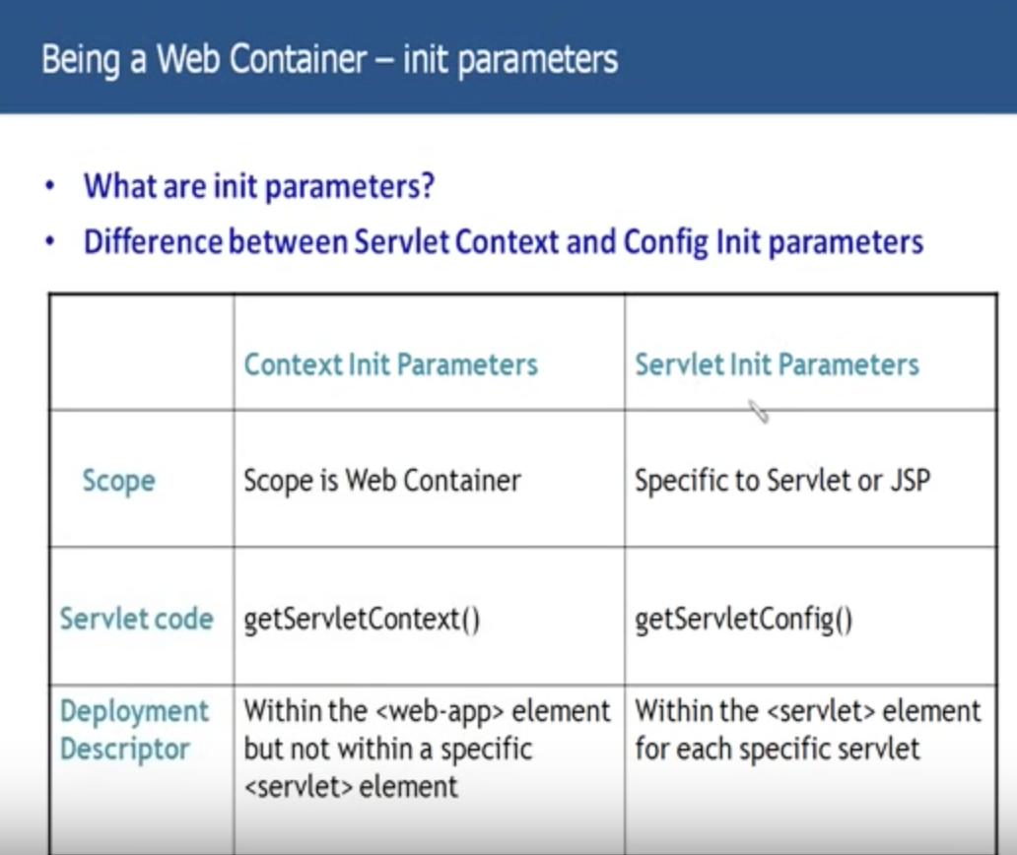

**Attributes:**

**What’s the difference between Attributes and parameters?**

